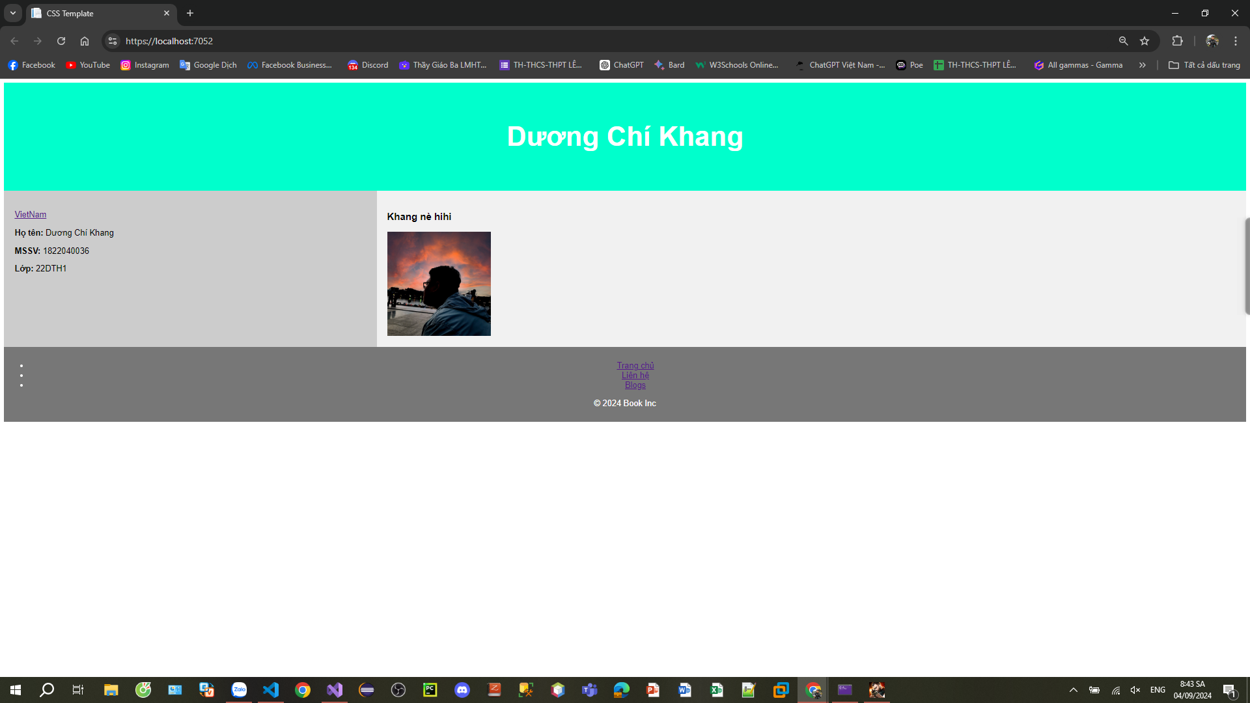

Layout = "";

<!DOCTYPE html>

<html lang="en">

<head>

<title>CSS Template</title>

<meta charset="utf-8">

<meta name="viewport" content="width=device-width, initial-scale=1">

<style>

\* {

box-sizing: border-box;

}

body {

font-family: Arial, Helvetica, sans-serif;

}

/\* Style the header \*/

header {

background-color: #00FFCC;

padding: 30px;

text-align: center;

font-size: 35px;

color: white;

}

/\* Create two columns/boxes that floats next to each other \*/

nav {

float: left;

width: 30%;

height: 300px; /\* only for demonstration, should be removed \*/

background: #ccc;

padding: 20px;

}

/\* Style the list inside the menu \*/

nav ul {

list-style-type: none;

padding: 0;

}

article {

float: left;

padding: 20px;

width: 70%;

background-color: #f1f1f1;

height: 300px; /\* only for demonstration, should be removed \*/

}

/\* Clear floats after the columns \*/

section::after {

content: "";

display: table;

clear: both;

}

/\* Style the footer \*/

footer {

background-color: #777;

padding: 10px;

text-align: center;

color: white;

}

/\* Responsive layout - makes the two columns/boxes stack on top of each other instead of next to each other, on small screens \*/

@@media (max-width: 600px) {

nav, article {

width: 100%;

height: auto;

}

}

</style>

</head>

<body>

<header>

<h2>Dương Chí Khang</h2>

</header>

<section>

<nav>

<ul>

<li><a href="#">VietNam</a></li>

<p><strong>Họ tên:</strong> Dương Chí Khang</p>

<p><strong>MSSV:</strong> 1822040036</p>

<p><strong>Lớp:</strong> 22DTH1</p>

</ul>

</nav>

<article>

<h1>Khang nè hihi </h1>

<img src="https://localhost:7052/img/h2.png" alt="It me " style="max-width: 100%; height: 200px;" />

</article>

</section>

<footer class="footer">

<ul class="footer-nav">

<li class="nav-item"><a href="#" class="nav-link">Trang chủ</a></li>

<li class="nav-item"><a href="#" class="nav-link">Liên hệ</a></li>

<li class="nav-item"><a href="#" class="nav-link">Blogs</a></li>

</ul>

<p>© 2024 Book Inc</p>

</footer>

</body>

</html>